Design Planning

# UML Diagrams

## Structure Diagrams

* Class Diagram - depicts the static structure of a system by showing system’s classes, their methods and attributes. Class diagrams also help us identify relationship between different classes or objects.

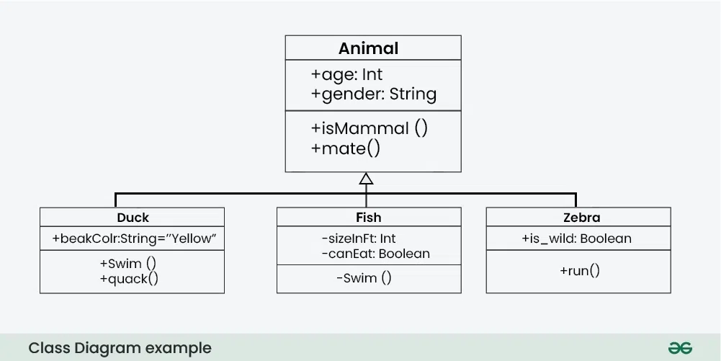

* Composite Structure Diagram - represent the internal structure of a class and its interaction points with other parts of the system. They are like class diagrams except they represent individual parts in detail as compared to the entire class.

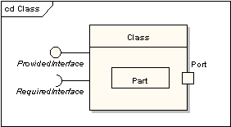

[More Info](https://www.edrawmax.com/article/composite-structure-diagram-explained.html)

* Component Diagram - used to represent how the physical components in a system have been organized. They depict the structural relationship between software system elements and help us in understanding if functional requirements have been covered by planned development.

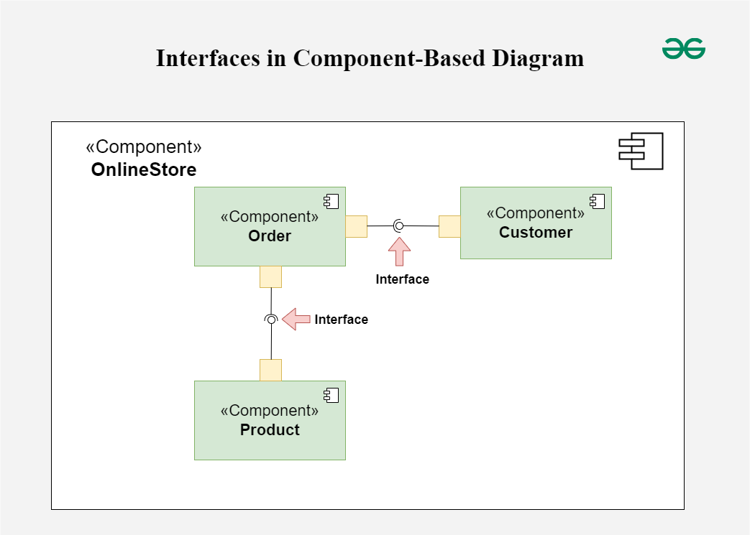

* Deployment Diagram - used to represent system hardware and its software. It tells us what hardware components exist and what software components run on them. They are primarily used when a software is being used, distributed or deployed over multiple machines with different configurations.

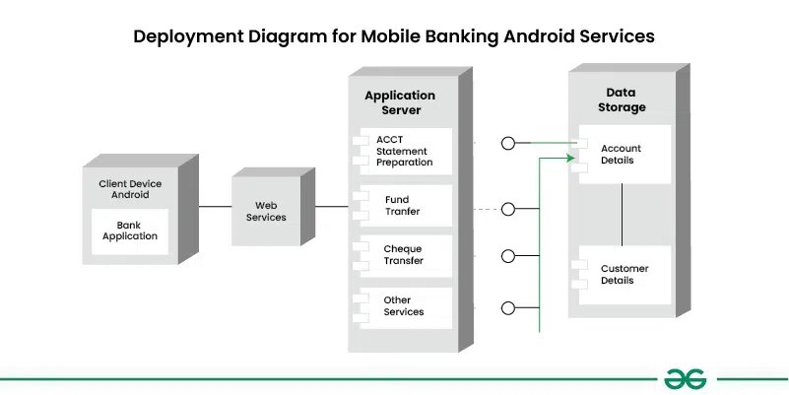

* Package Diagram - depict how packages and their elements have been organized. A package diagram simply shows us the dependencies between different packages and internal composition of packages. They are primarily used to organize class and use case diagrams.

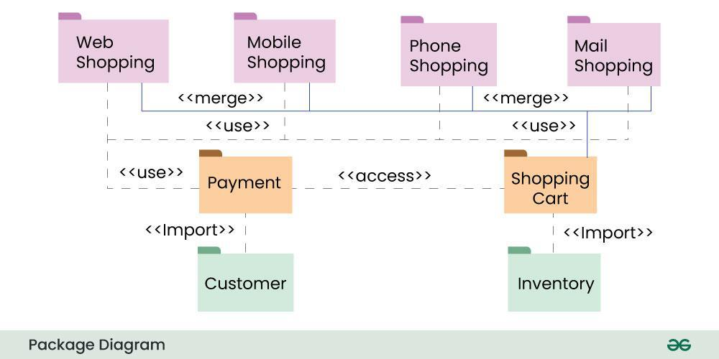

* Object Diagram - a screenshot of the instances of classes in a system (objects) and the relationship that exists between them. Since object diagrams depict behavior when objects have been instantiated, we are able to study the behavior of the system at a particular instant.

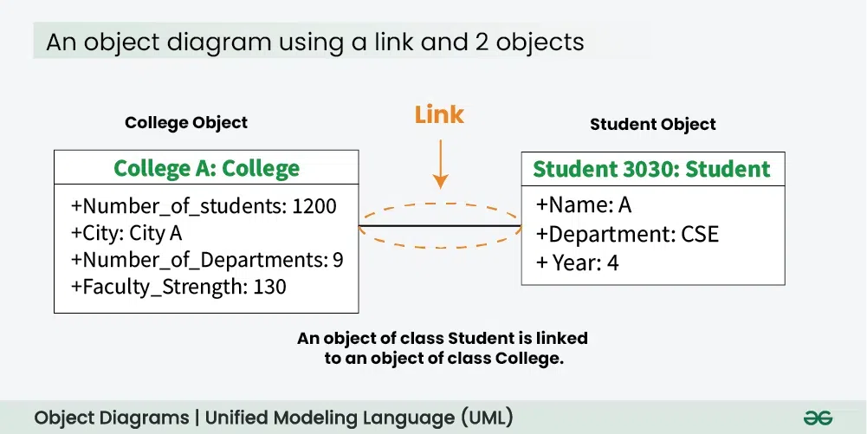

## Behavior Diagrams

* Activity Diagram - illustrate the flow of control in a system and refer to the steps involved in the execution of a use case. An activity diagram models sequential and concurrent activities; depicts workflows visually; focuses on condition of flow and the sequence in which it happens; and depict what causes a particular event using an activity diagram.

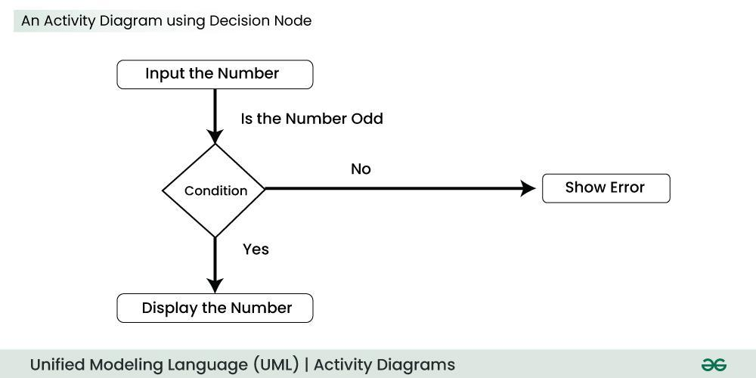

* Interaction Diagrams
  + Communication Diagram - used to show sequenced messages exchanged between objects. A communication diagram focuses primarily on objects and their relationships.

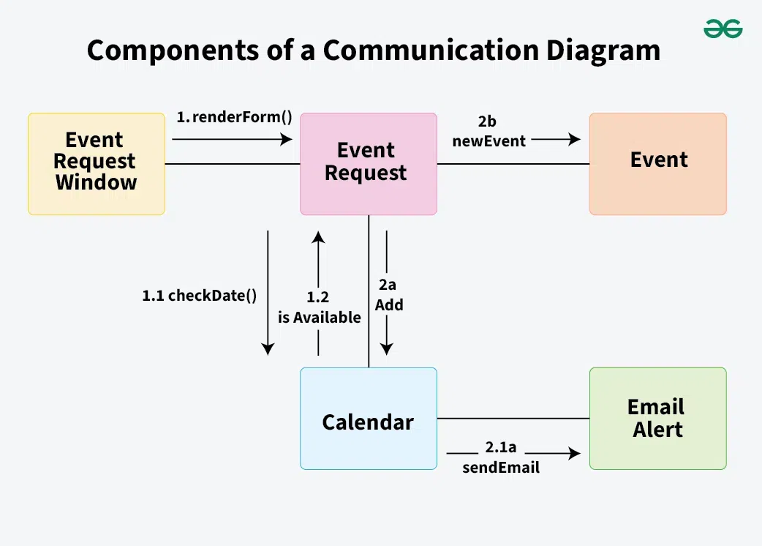

* + Interaction Overview Diagram - illustrates the flow of interactions between various elements in a system or process. It provides a high-level overview of how interactions occur, including the sequence of actions, decisions, and interactions between different components or objects.

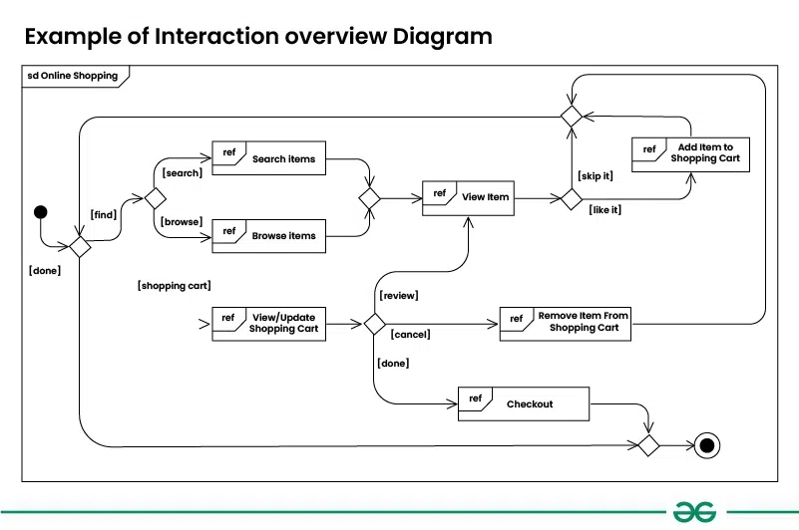

* + Sequence Diagram - depicts interaction between objects in a sequential order i.e. the order in which these interactions take place. Sequence diagrams describe how and in what order the objects in a system function.

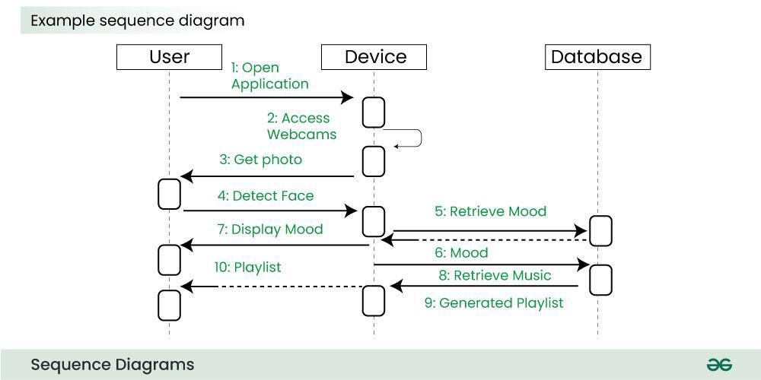

* + Timing Diagram - a special form of Sequence diagrams which is used to depict the behavior of objects over a time frame. They are used to show time and duration constraints which govern changes in states and behavior of objects.
* State Machine Diagram - used to represent the condition of the system or part of the system at finite instances of time. A state diagram is used to model the dynamic behavior of a class in response to time and changing external stimuli.

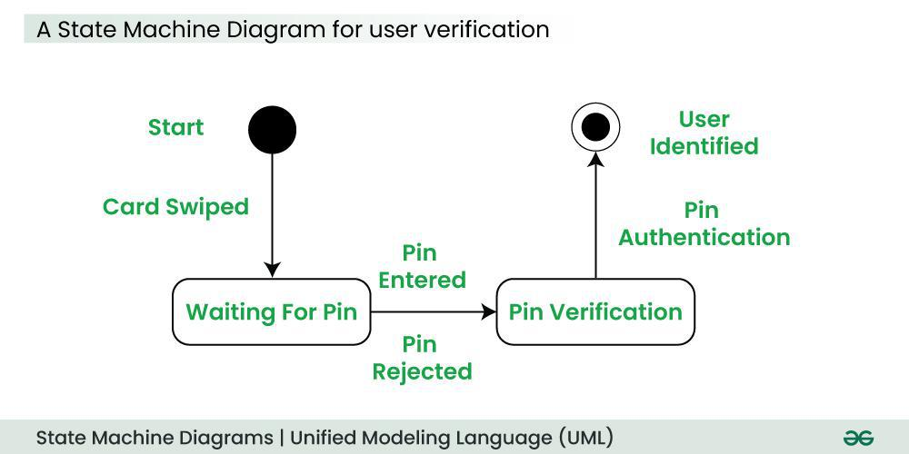

* Use Case Diagram - depicts the functionality of a system or a part of a system. They are widely used to illustrate the functional requirements of the system and its interaction with external agents(actors).

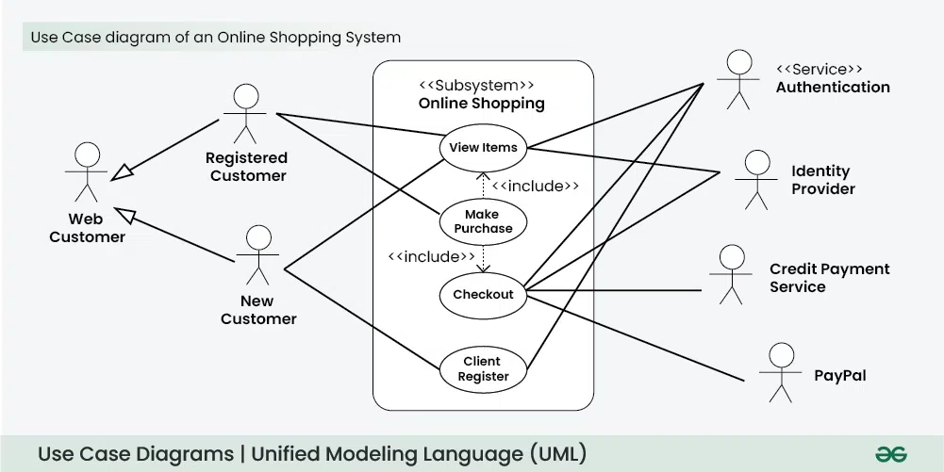

# Other Diagrams

## Structure Diagrams

* Mind Map/Site Map - a visual organizational tool that uses a central concept or idea, surrounded by branches that represent related ideas and subtopics. It's a way to brainstorm, organize thoughts, and create connections between different pieces of information.

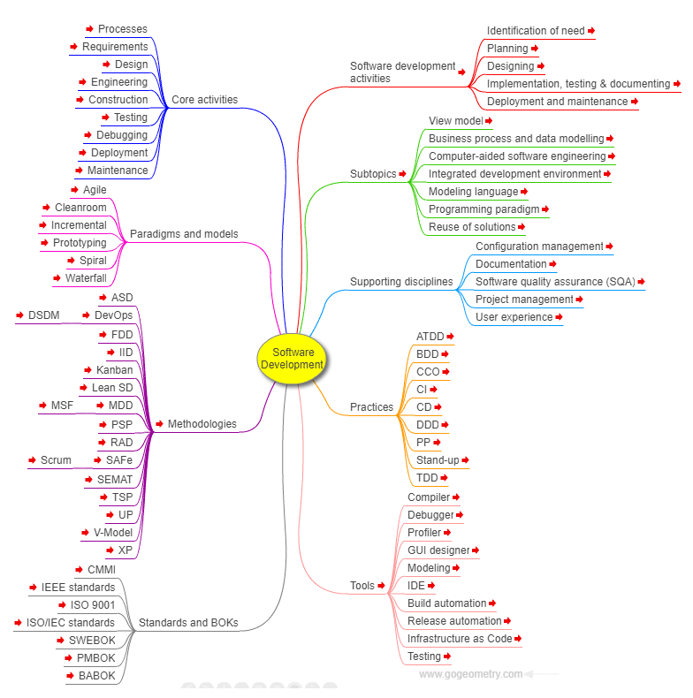

* Salt (GUI Designer) - a subproject included in PlantUML to design graphical interfaces.

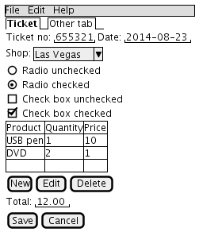

* Entity-Relationship Diagram - a visual representation that shows how different entities relate to each other within a system, often a database or a business process.

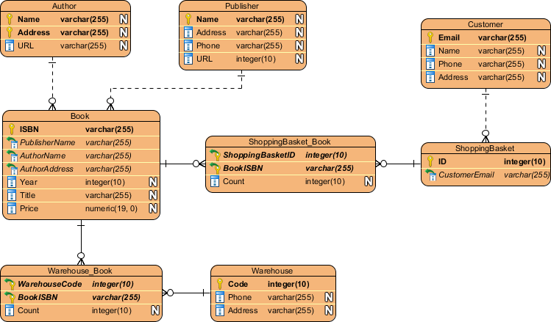

## Project Management Diagrams

* Work Breakdown Structure Diagram (WBS) - a hierarchical decomposition of a project into smaller, more manageable components or tasks. It's a visual representation that breaks down the entire project scope into a clear, organized structure, making it easier for project teams to plan, schedule, and track progress.

